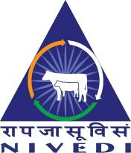
भाकृअनुप–राष्ट्रीय पशरोगु जानपदिक एवंसचनाू ववज्ञान संस्थान

ICAR–National Institute of Veterinary Epidemiology and Disease Informatics

रामगोंडनहल्ली, येलहंका,बेंगलरूु – 560064 Ramagondanahalli, Post Box No: 6450, Yelahanka, Bengaluru-560064

Ph: +91 80 23093110/+ 91 80 23093111 Fax: + 91 80 23093222, Email: director.nivedi@icar.gov.in

Report on Celebration of National Productivity Week from 12th February to 18th February 2017 at ICAR-National Institute of Veterinary Epidemiology and Disease Informatics (NIVEDI, Yelahanka, Bengaluru-560064

ICAR-NIVEDI, Bengaluru is a unique Institute carrying out its research programmes on Epidemiology, surveillance, forecasting, forewarning for management of animal diseases including zoonoses. It is the epidemiological time keeper of animal diseases. As per the instructions from the National Productivity Council, New Delhi, ICAR-NIVEDI celebrated national Productivity Week from 12-18th February 2017.
On 12th February 2017: Displayed the Banner depicting the celebration of National Productivity Week 2017 and creating the awareness about National Productivity Week-2017
13th February 2017: Dr. Parimal Roy, Director, ICAR-NIVEDI, Bengaluru inaugurated the programme and stressed to minimize the waste and waste materials need to be utilized effectively by recycling them. Dr. S. S. Patil, Senior Scientist, ICAR-NIVEDI presented a detailed deliberations on “Quick Reference to Material Flow Cost Accounting” and discussed on various things related to laboratory waste managements.
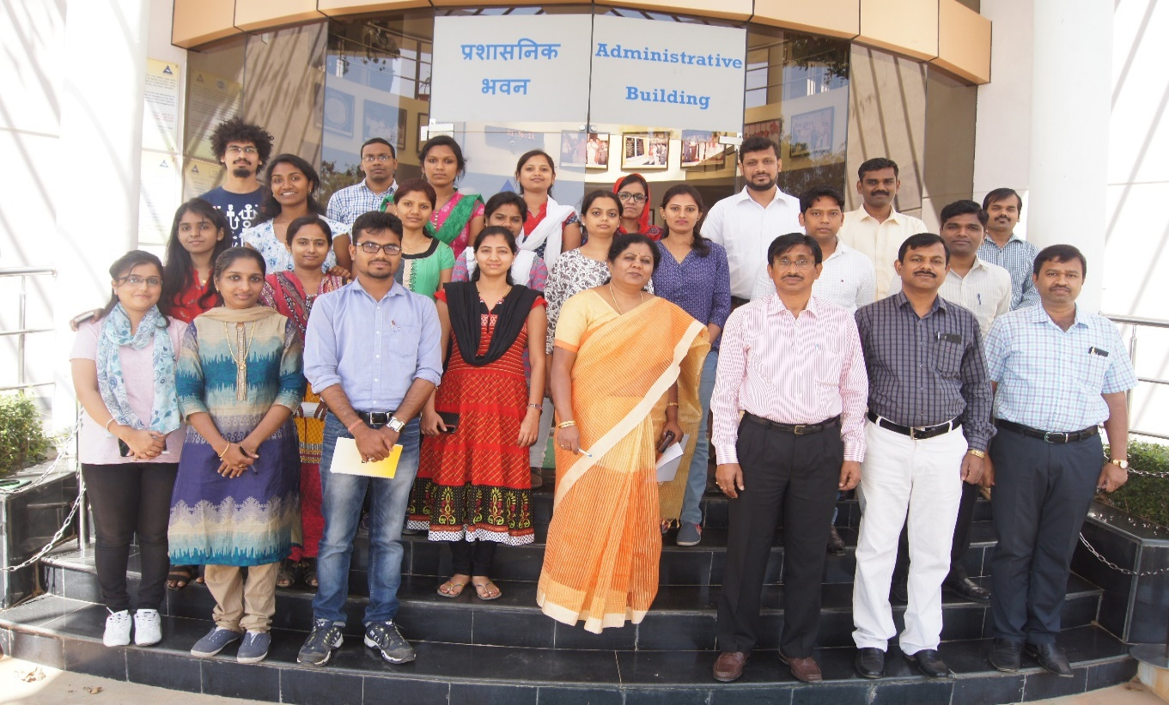
Staff of ICAR-NIVEDI, Bengaluru who participated in the inaugural programme on 12 February 2017

14th February 2017: A competetion on the presentation of the theme are viz., “From waste to profit through reduce, recycle and reuse” was arranged. Three prizes were awarded. First prize was bagged by Dr. G.B.M. Reddy, Scientist, Second prize was bagged by Ms. K.N. Mandara, Project Assistant and the third prize was taken away by Mrs. N.O. Shruthi, Young Professional I (YP I).
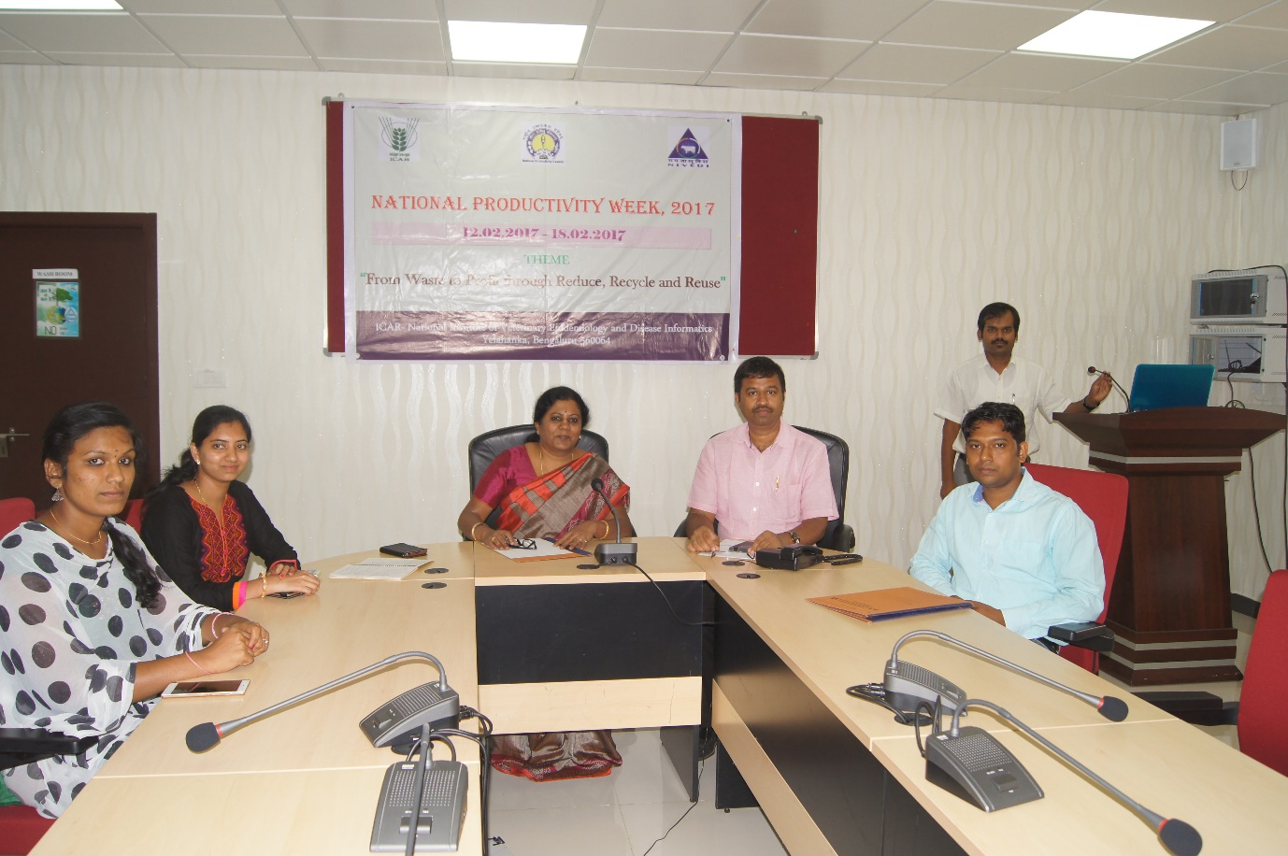
Presentations on the theme area: From waste to profit through Reduce, Recycle and Reuse
Dr. Parimal Roy, Director of the institute giving away the prizes to the winners of Elocution competition

On 15th February 2017: Essay writing completion was conducted on the topic: Efficient utilization of laboratory resources to increase productivity. Ms. Sowjanyakumari, SRF bagged the first prize. Mrs. Saranya, Stenographer and Mr. Ravichanda bagged second and third prizes respectively.
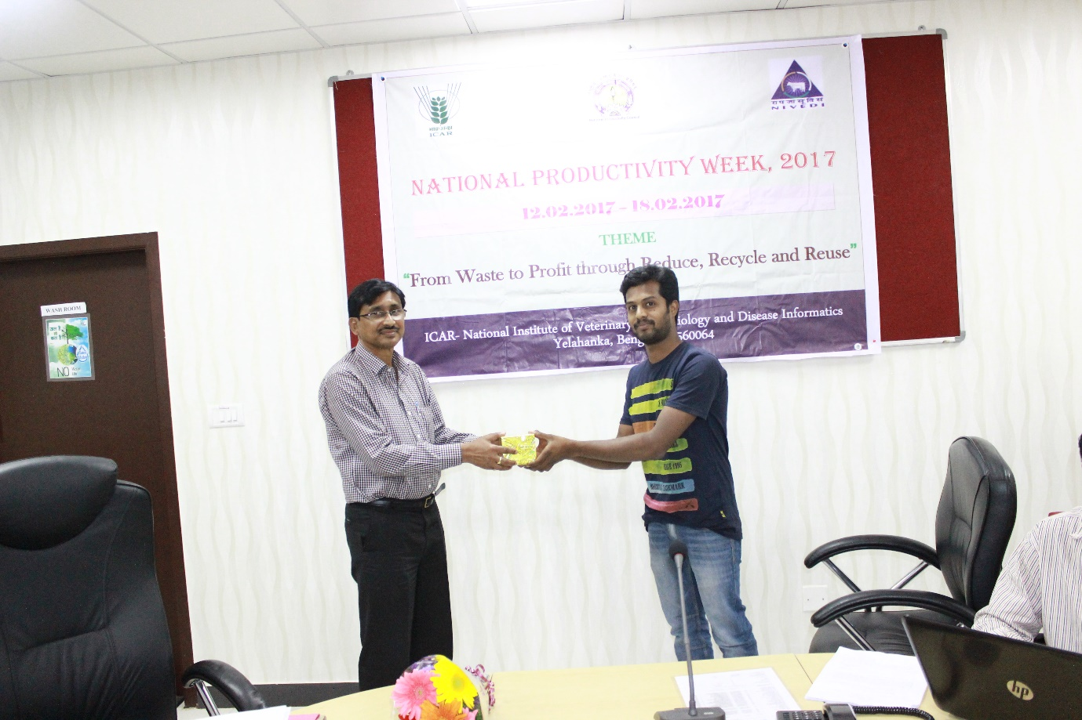
Dr. Parimal Roy, Director of the institute giving away the prizes to the winners of Essay Competition

On 16th February 2017: Painting competition was held on the theme area. Mrs. N.O. Shruthi, YP I bagged the 1st prize followed by Ms. Sowjanyakumari, SRF bagged the second prize and the third prize was shared by Mrs. Tanuja, YP I and Mr. Ravichandra.

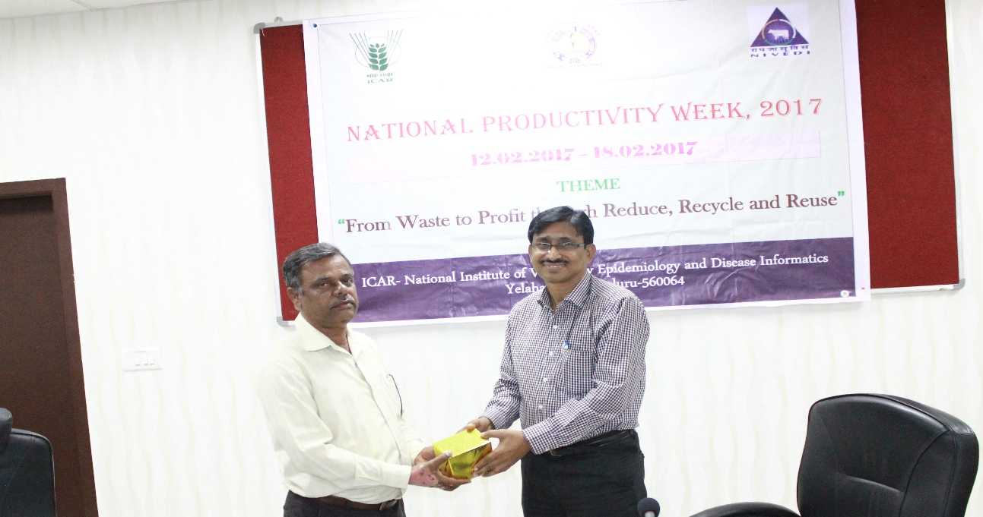
Dr. Parimal Roy, Director of the institute giving away the prizes to the winners of painting competition
Valedictory Programme was conducted and the Dr. Parimal Roy, Director of the institute appreciated the endeavours made by Dr. S.S. Patil, Senior Scientist and Dr. Awadhesh Prajapati, STO to make the event successful.

