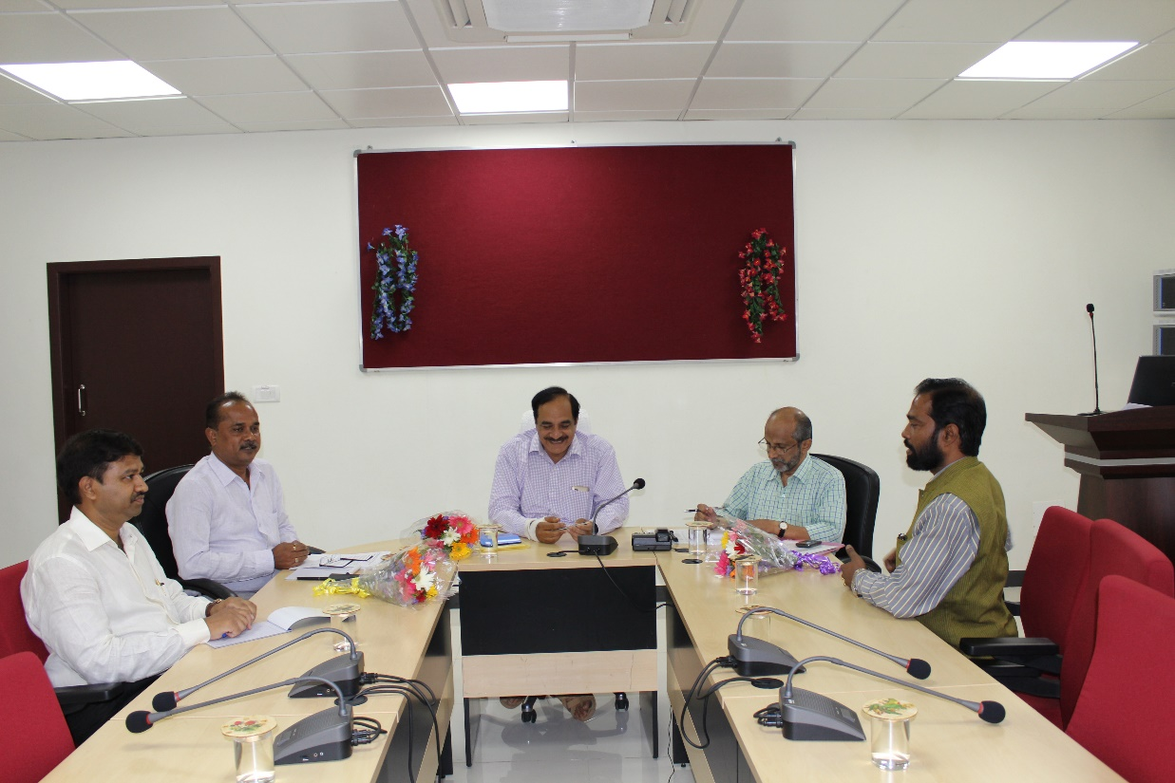
Dr.S.S. Patil, Senior Scientist, Nodal Officer organized Sub-committee review meeting of DBT Network Project on Classical Swine Fever on 11th April 2016 at ICAR-NIVEDI, Bengaluru. Dr.H.V. Batra, Director (Retd), DFRL, Mysuru Chaired the meeting. Other members present were, Dr. B. R. Shome, Director (Acting), ICAR-NIVEDI, Dr. K. Kumanan, Dean, TANUVAS, Dr. Saikumar, Principal Scientist, IVRI, Izatnagar.

